Traffic Sign Recognition Using Deep Learning
Sanya Bansal
Department of Computer Science and Engineering
Chitkara University Institute of Engineering and Technology
Chitkara University, Punjab, India
sanya2256.be22@chitkara.edu.in
Vishesh
Department of Computer Science and Engineering
Chitkara University Institute of Engineering and Technology
Chitkara University, Punjab, India
Vishesh2539.be22@chitkara.edu.in

Shivanshu Saini
Department of Computer Science and Engineering
Chitkara University Institute of Engineering and Technology
Chitkara University, Punjab, India shivanshu2331.be22@chitkara.edu.in
Sharad Jindal
Department of Computer Science and Engineering
Chitkara University Institute of Engineering and Technology
Chitkara University, Punjab, India sharad2286.be22@chitkara.edu.in

Abstract—Automating traffic sign recognition through intelligent systems can significantly lower the global incidence of road accidents. Automated detection and interpretation of traffic signs form a pivotal component of any Intelligent Transportation System (ITS). In the era of autonomous vehicles, the need for automatic traffic sign detection and interpretation is more pressing than ever. This work proposes a deep-learning-driven autonomous framework for identifying traffic signs. The proposed automatic traffic sign detection and recognition approach was evaluated on a novel dataset containing 6480 images encompassing 7056 sign instances across 87 classes. We introduce multiple refinements to the Mask R-CNN, spanning both architectural tweaks and data augmentation strategies. Our study includes highly challenging traffic sign classes not commonly addressed in prior research. The training and evaluation datasets were built from images captured in real-world road conditions. Experimental results demonstrate an error rate below 4%. Additionally, RMR-CNN’s outcomes were compared with standard deep architectures such as Fast R-CNN and Mask R-CNN. Our proposed approach attained a precision of 96.18%, exceeding the precision scores achieved by Mask R-CNN and Faster R-CNN variants.
Keywords: Refined Mask R-CNN , Fast R- CNN , Data - augmentation , Pre- processing , Custom dataset , Traffic Sign
- INTRODUCTION
Intelligent vehicles, including driverless cars, demand autonomous traffic sign detection and recognition (TSDR). Since the early reporting by Kamada et al. in the 1990s, numerous techniques have been devised for automatic traffic sign detection and recognition. Many successful studies have leveraged computer vision for automatic TSDR, as reviewed in Zhu et al. (2016a,b). Much of the prior TSDR research, especially outside India, has concentrated on a relatively small set of categories related to Advanced Driver Assistance Systems (ADAS) (Timofte et al., 2011). Consequently, benchmark datasets for TSDR often include only a limited selection of sign types focused primarily on recognition (Zaklouta and Stanciulescu, 2012; Zhu et al., 2016a,b). Detecting other sign categories that exhibit large appearance variations, and which are excluded from standard tests and annotations, remains challenging. Several TSDR studies target signs from countries other than India, and publicly available datasets are comparatively few, such as the Laboratory for Intelligent and Safe Automobiles (LISA) (Mogelmose et al., 2012), MASTIF Croatia (Segvic et al., 2010), the German Traffic Sign Detection Benchmark (GTSDB) (Houben et al., 2013), and the German Traffic Sign Recognition Benchmark (GTSRB). Traditional approaches for traffic sign detection and recognition rely on deep neural networks. Within these networks, Convolutional Neural Networks (CNNs) have driven significant progress in image tasks. Frameworks such as Fast Region-Based CNNs (F-CNN) and Mask R-CNN (Aziz et al., 2020) were trained and validated on datasets from foreign roads; therefore, their direct application to Indian road scenes may not yield optimal performance

- LITERATURE REVIEW
This paper examines an optimized Refined Mask R-CNN (RMR-CNN) model tailored for traffic sign detection and recognition on Indian roads. The accuracy gains in RMR-CNN stem from modifications to Mask R-CNN supplemented by several preprocessing steps: shape detection, region of interest (ROI) extraction, color probability estimation, parametric adjustments, and data augmentation. The central aim of this study is to identify approaches that help reduce road accidents. Reducing accidents not only saves lives but also safeguards people’s livelihoods. ADAS systems are among the most practical measures to lower accident rates; traffic sign recognition is a core aspect of ADAS. Recognition of traffic signs has not yet been exhaustively explored; the practical effectiveness of leading deep-learning approaches such as Mask R-CNN and Fast R-CNN for traffic sign interpretation remains to be fully validated. This research adopts a deep-learning approach trained on a custom dataset to detect and understand traffic signs and to evaluate recognition accuracy. Unlike the relatively large sign datasets available for other countries, comprehensive datasets for Indian traffic signs are scarce. The lack of a standardized dataset covering a broad set of sign categories complicates selection of the most suitable algorithms for TSDR. Existing datasets show wide variation in image counts, accuracy, and computational time. We built an original dataset for Indian traffic signs using deep-learning-driven collection and annotation. Training and testing datasets were formed by capturing images and categorizing them based on contained sign instances. Only manually installed traffic signs were included; electronic signs were excluded. To our knowledge, this dataset formulation approach for Indian traffic signs is novel. The primary contribution of this work is the deployment of the proposed RMR-CNN—a Mask R-CNN variant with multiple improvements—to a large and diverse set of traffic signs. Sign instances underwent scaling, rotation, lighting variation, and intra- and inter-category variability. For evaluation, detection performance on the custom dataset was compared to Fast R-CNN, and recognition performance was compared against Mask R-CNN. Among R-CNN family models—Fast R-CNN, Faster R-CNN, and Mask R-CNN—each successive variant improves upon the previous; Mask R-CNN is widely adopted for its reliability. Our RMR-CNN further enhances Mask R-CNN’s accuracy. The following section surveys contemporary methods for traffic sign detection and recognition. Section III describes the custom dataset covering road traffic signals. Subsequent sections detail the refined Mask R-CNN architecture for detection, the recognition approach, and finally the evaluation and results for RMR-CNN.
III. SYSTEM ARCHITECTURE
This section briefly reviews prior traffic sign detection studies worldwide. Luo et al. (2018) proposed a three-stage data-driven system using a vehicle-mounted camera to recognize both symbolic and text-based signs: ROI extraction, ROI refinement and classification, and post-processing; however, their approach suffered from long post-processing times. Mammeri et al. (2013) addressed TSDR challenges relevant to ADAS but their system operated over a limited frequency range and struggled with low-resolution cameras and vehicle-induced vibrations. Lee and Kim (2018) developed a CNN-based detector that simultaneously estimated sign location and precise boundaries; while accurate, their method required very high-resolution images. Hu et al. (2016) proposed a single learning-based detector handling three object classes—signs, cars, and bicycles—using a small number of sub-detectors to keep detection times low; adding detectors for more object types, however, increased runtime. Greenhalgh and Mirmehdi (2012) identified sign regions as maximally stable extremal regions (MSER) and recognized signs via SVMs trained on HOG features; precision and recall were 86% and 80%, respectively. Later, Greenhalgh and Mirmehdi (2015) leveraged scene structure to prioritize search regions for signs; removing structural cues raised false positives and lowered frame rates from 14 fps to 6 fps. Huang et al. (2017) proposed a two-module method using HOG features and a classifier trained with Extreme Learning Machine (ELM), but performance depended on parameter tuning and misclassification exceeded 50%. Huang et al. (2020) suggested a visual-inspection-based recognition method, which achieved lower average precision than our RMR-CNN. Yang et al. (2016) combined SVM and CNN for fast detection but reported lower accuracy than leading methods like Mask R-CNN. Chen and Lu (2016) used AdaBoost and SVR for detection. Liu et al. (2016) proposed a TSR method based on high-contrast region extraction and extended sparse representation; however, color enhancement of other objects led to delays. Temel et al. (2020) developed a spectral approach resilient to weather and dirty lenses but achieved around 80% accuracy. Kamal et al. (2019) introduced SegU-Net (Seg-Net + U-Net) for TSDR and reported 95.29% precision on the German dataset—lower than some CNN+STN approaches. Wong et al. (2018) proposed Micro-Net, a compact network for TSR. Advanced detectors like Mask R-CNN and Faster R-CNN are computationally efficient. Avramovic´ et al. (2020) applied YOLO-based CNNs for HD images using region focusing and parallelization to boost speed and accuracy, but region selection risks missing actual signs. Guo et al. (2020) highlighted challenges in detecting and recognizing Chinese text on signs, where occlusion caused misrecognition. Zhang et al. (2017) used seam carving detection along with Weber Local Descriptor (WLD) and Local Binary Patterns (LBP) for image tampering detection. Zhou and Qiu (2021) improved SSD by allowing interaction between low- and high-level feature maps and adopting parallel detection structures. Zhang et al. (2021) improved object tracking under deformation and illumination using ResNet features and cascaded correlation filters; Zhang et al. (2020) proposed cascaded correlation filters combining handcrafted and ResNet features and noted challenges in seam carving at low scaling ratios, using co-occurrence of adjacent LBPs with SVM classification for seam-carving detection. Lopez-Montiel et al. (2021) observed a lack of standardized guidance for choosing hardware and algorithms for TSD, and proposed a methodology to evaluate GPU and TPU performance using combinations of models (ResNet50 v1, MobileNet v1) with SSD and Feature Pyramid Network (FPN) on the LISA dataset, concluding TPU was 16.3× faster than GPU and produced higher precision.
IV. METHODOLOGY AND IMPLEMENTATION
Road traffic signs play a vital role in protecting vehicles, drivers, passengers, and pedestrians and in limiting property damage. Signs are generally categorized as:
- Mandatory or Regulatory signs
- Cautionary, Precautionary or Warning signs
- Informative signs
Mandatory signs impose required actions; disregarding them is illegal. Cautionary or warning signs alert drivers to slowdowns, roadworks, hazards, or accidents ahead. Informative signs guide users about directions, routes to destinations, and roadside amenities like food, lodging, rest areas, restrooms, and fuel stations.
The custom dataset developed for this study comprises 6480 images containing 7056 traffic sign instances, distributed into 100 categories based on sign instances within the images. Thirteen of these categories were sourced from standard datasets such as Deutsche Forschungs Gemeinschaft (DFG), where signs match local shapes. Of the 6480 images, 4544 were captured in real-world conditions and categorized into 87 sign classes; the remaining 1936 images were collected from public sources (Jharkhand Police Department, India Mart, SlideShare) ensuring only copyright-free images were used. Each class contains at least 32 images. Approximately 70.12% of images are high resolution (4128 × 2322 px, 774 × 1032 px, 960 × 1280 px), while 29.8% are low resolution (225 × 225 px, 200 × 200 px). There are 200 images containing two sign instances, 40 images containing three, and 32 images containing four. Around 97% of sign instances are clearly visible; 3% are faint. Sample dataset images appear in Figs. 1–3.
Images in the custom dataset are split into two groups: signs over 30-pixel resolution and signs over 50-pixel resolution. A small number of bounding boxes are under 30 pixels, typically in images with multiple identical signs; such instances were excluded from training and testing. The majority of sign instances exceed 30 pixels. Instances under 30 pixels were ignored because down sampling in Faster R-CNN and Mask R-CNN maps 32×32 pixels to a single 1×1 pixel in feature maps. Standard 80:20 train-test split was applied, ensuring at least six images per class in the test set and a minimum of 32 images per class. The split was randomized, yielding 5664 training images and 1412 test images.
Redefined Mask-RCNN
for traffic sign detection This segment discusses the RMR-CNN detection system which refines Mask R-CNN in several ways. We summarize Mask R-CNN briefly, then outline parameter adjustments and enhancements in architecture and data augmentation. The refined Mask R-CNN is depicted in Fig. 4.
Mask R-CNN
CNN-based deep networks have revolutionized image analysis. Frameworks like Fast R-CNN and Mask R-CNN are commonly trained on datasets from foreign roads and might not generalize well to Indian roads. Fast R-CNN improves on R-CNN by using Region Proposal Networks (RPNs), whereas Mask R-CNN improves upon Faster R-CNN by producing a segmentation mask in addition to bounding boxes. Faster R-CNN often yields bounding boxes that include background pixels; Mask R-CNN outputs a binary mask indicating pixel-level object membership. High accuracy in RMR-CNN is achieved by modifying CNN architectures and performing targeted data augmentation.
Pre-processing for better accuracy
Three preprocessing stages are applied before Mask R-CNN: shape detection, ROI extraction, and color probability estimation.
Shape Detection: This initial step identifies geometric shapes in frames captured from live video. After locating shapes, both color and grayscale versions of the image are used. The camera’s color frames are first converted to grayscale, then contour detection via OpenCV is applied to retrieve contour values. Contour areas are computed, and shapes of traffic signs are inferred using area thresholds specified by the user. Resulting crops proceed to the ROI module. Figs. 5(a) and (b) show sample images for ROI detection. Fig. 6 presents dataset samples and their annotation masks obtained using the shape detection approach. Annotation masks are produced by applying shape detection to original images and cropping according to detected sign coordinates.
Region Of Interest (ROI): Precise localization of a traffic sign depends on extracting the correct ROI. Most Indian signs appear within triangles, rectangles, or circles; the RMR-CNN is designed to detect these shapes in images. Processing unnecessary areas can lead to incorrect predictions and longer processing times. We use three algorithms to detect ROIs: Hough Circle for circular ROIs, and contour and edge detection for triangular and rectangular ROIs. Each shape-specific routine marks the ROI boundary with a color. Images are cropped using a 5% threshold to retain ROI content without loss. Cropped images are converted back to color for the subsequent colour probability step. Fig. 1. First collage of Custom dataset. 54 images, many of them close up images, of various traffic signs in various positions, orientations and light settings are shown. Colour probability is used to find the percentage of RGB pixel values in the image. Fig. 7(a), 7(b) and 7(c) display ROIs corresponding to samples in Fig. 5: 7(a) corresponds to ROI in 5(a), 7(b) is the grayscale ROI for 5(a), and 7(c) is the ROI for 5(b).

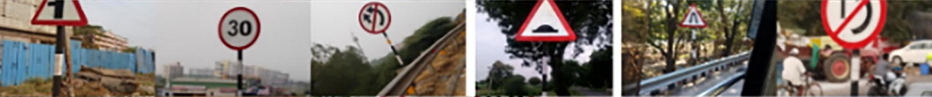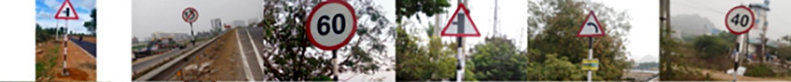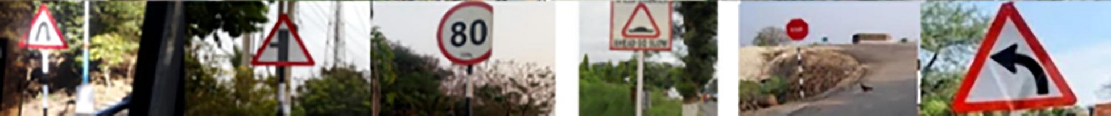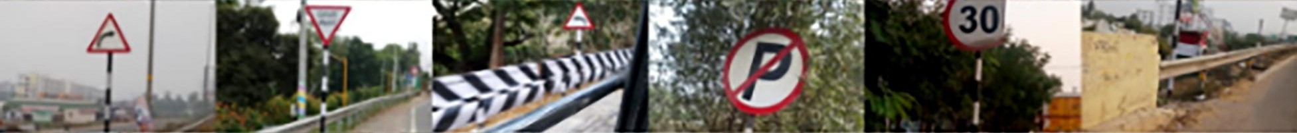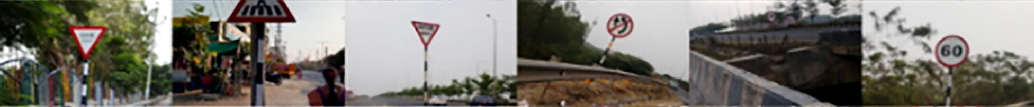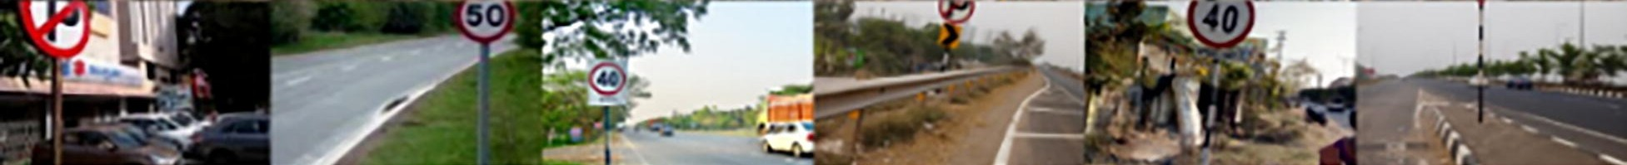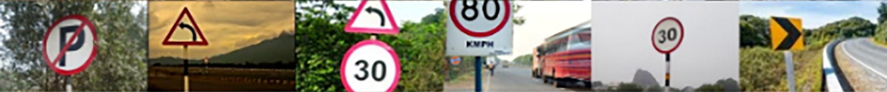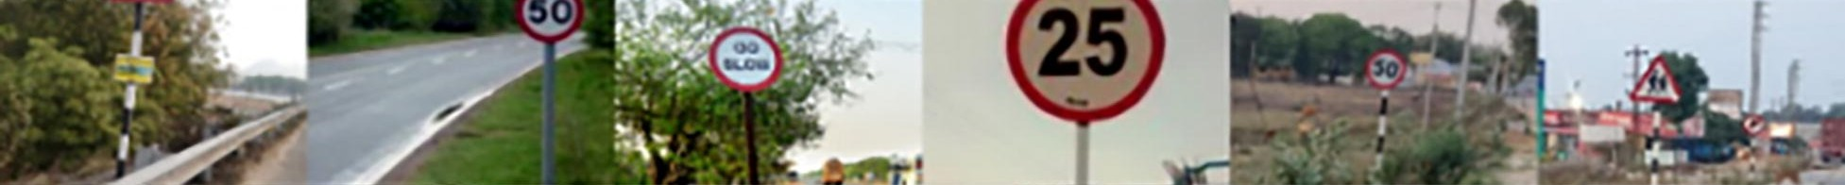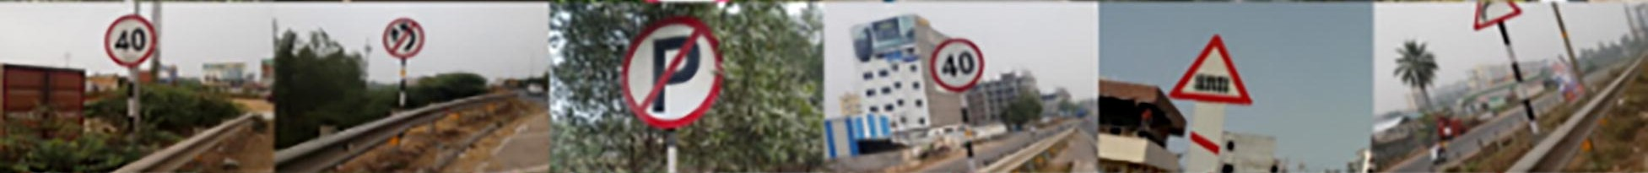

Fig. 1. First collage of Custom dataset. 54 images, many of them close up images, of various traffic signs in various positions, orientations and light settings are shown.

Colour Probability: Here, the RGB values of each pixel in the cropped sample are computed and stored in a dataset. Various lighting situations—sunlight on the sign, sunlight from behind, and low-light conditions—were examined to determine ranges of RGB values. From the dataset, we count pixels that fall into red, black, and white ranges using real-time range calculations. For each pixel, counters for red, black, and white increment depending on which range the pixel falls into. We computed RGB ranges for signs both facing the sun and away from the sun. After color probability estimation, images meeting a threshold derived from the training set are forwarded to the model. Fig. 2. Second collage of Custom dataset. 49 images of various traffic signs in various positions, orientations, light settings and at various distances are shown in this collage. Fig. 3. Third collage of Custom dataset. 100 images of various traffic signs in various positions, orientations, light settings and at various distances are shown in this collage.

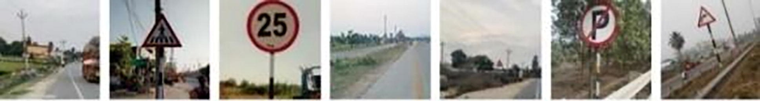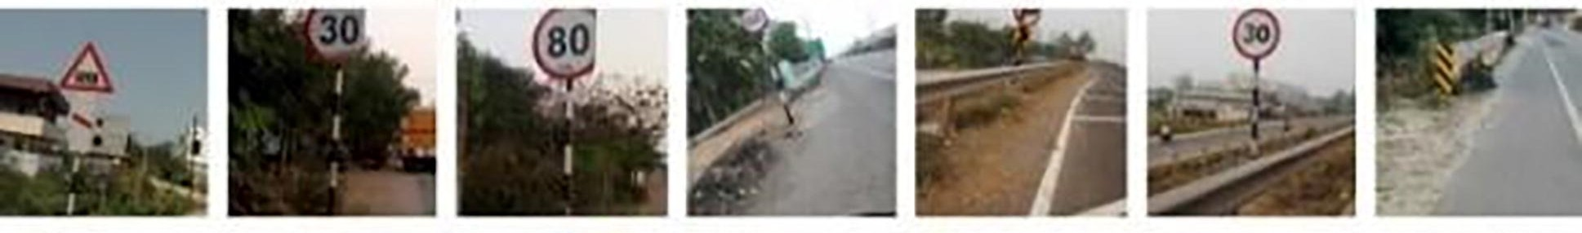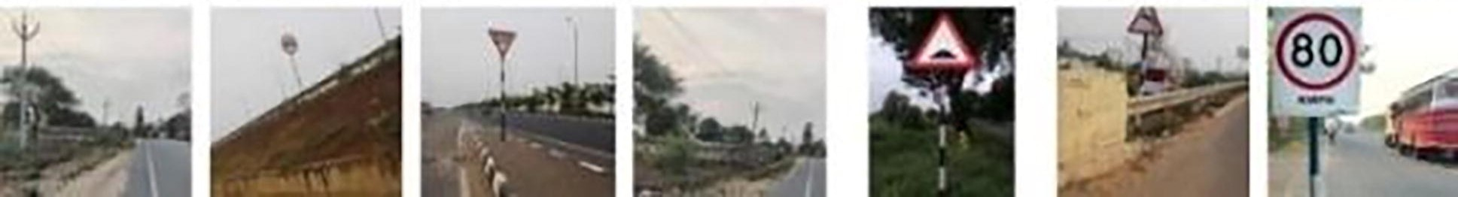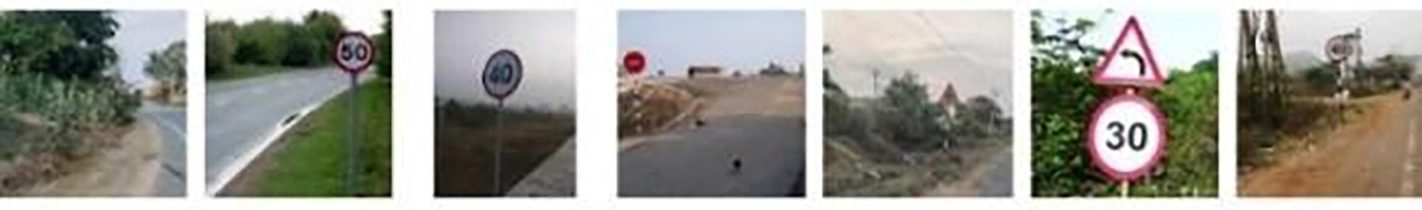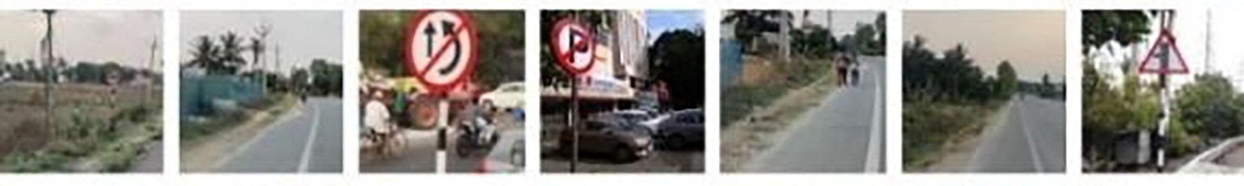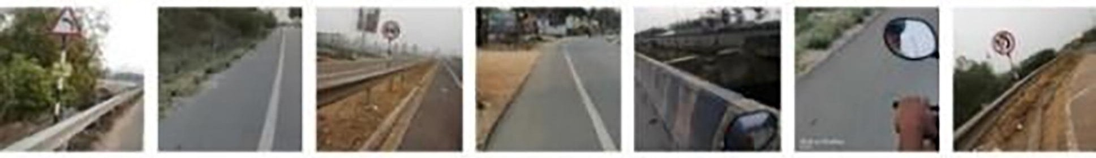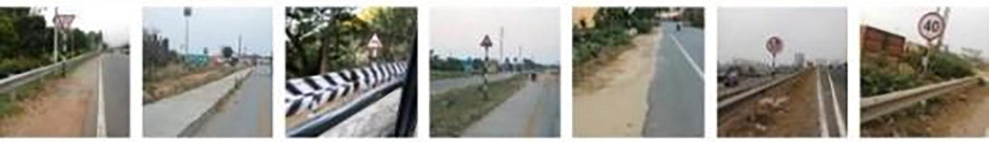
Fig. 2. Second collage of Custom dataset. 49 images of various traffic signs in various positions, orientations, light settings and at various distances are shown in this collage.

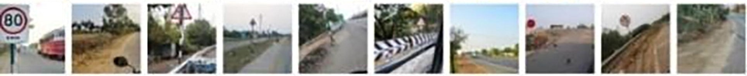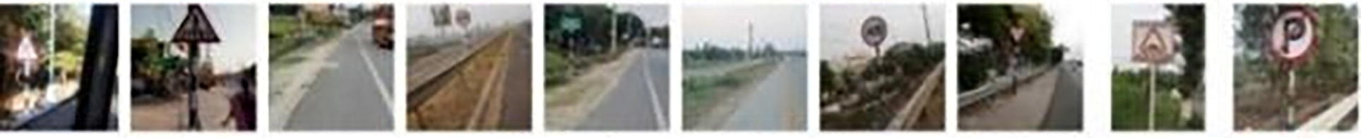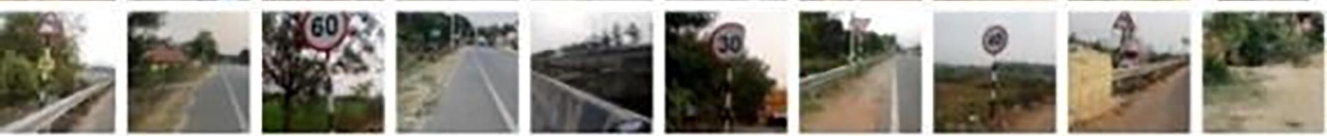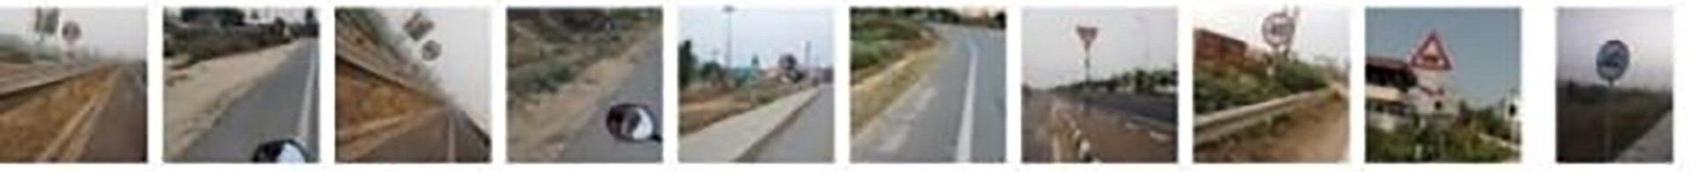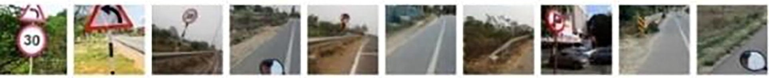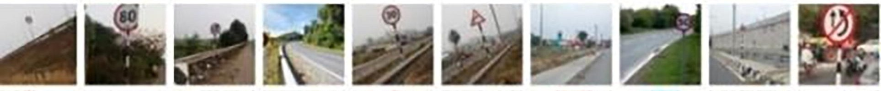
Fig. 3. Third collage of Custom dataset. 100 images of various traffic signs in various positions, orientations, light settings and at various distances are shown in this collage.

Fig. 8(a)
Colour
RGB Values
Red (218,88,96)
White (240,232,221)
Black (67,54,45).

Fig. 8(b)
Colour
RGB Values
Red (212,32,44)
White (218,218,216)
Black (45,45,61)

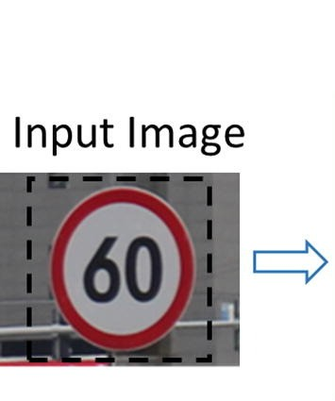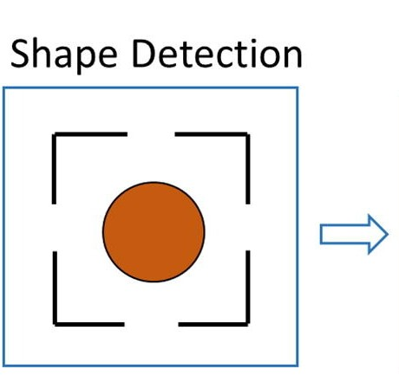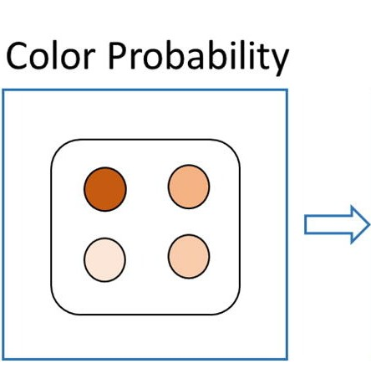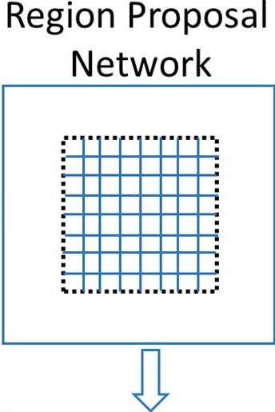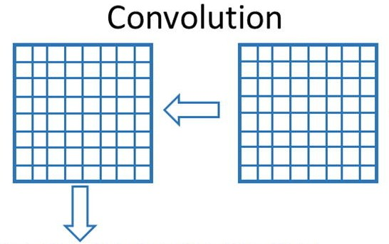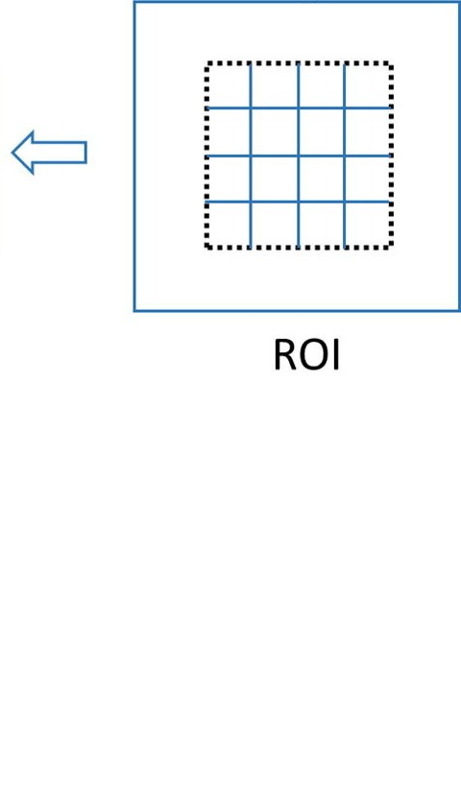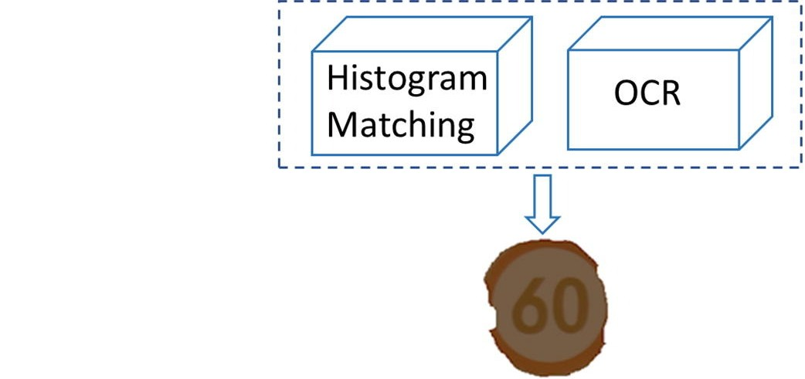
Fig. 4. Refined Mask R-CNN model. Mask R-CNN with shape detection, colour probability based on lighting conditions, histogram matching, and optical character recognition (OCR) is proposed for TSD and TSR.

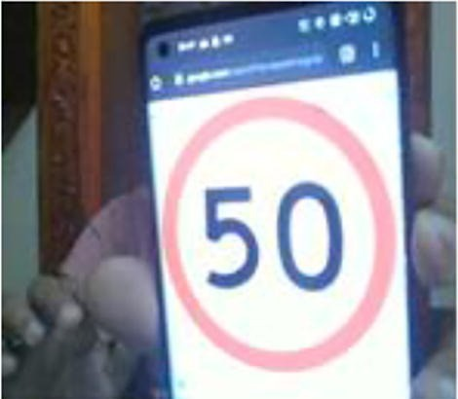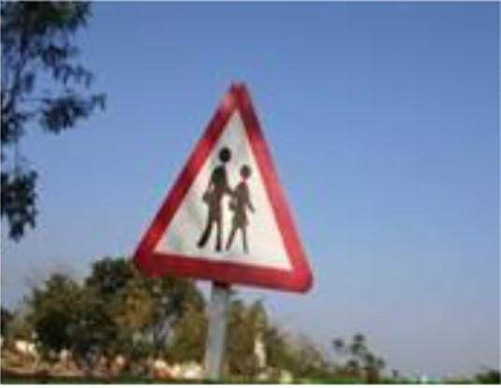
Fig. 5. Sample images used for finding ROI

By analyzing more images, color ranges for each hue were calculated and incorporated into the color probability module. Fig. 8 illustrates examples where 8(a) is partially sunlit and 8(b) is fully sunlit. We computed RGB ranges for red, black, and white on the 0–255 scale and plotted pixel counts (Fig. 9): 9(a) corresponds to image 8(a) and 9(b) to image 8(b). From these plots, color percentages are computed as:
color percentage =¼ count of (color pixel) / (total number of pixels)
(1) Using this method, thresholds were set to 12% for red, 15% for white, and 9% for black.

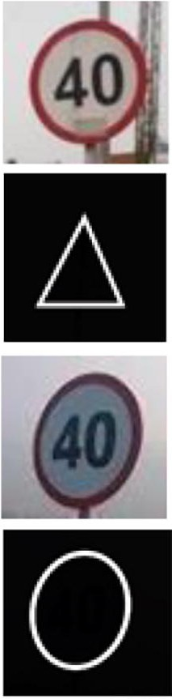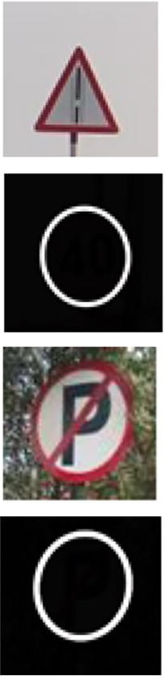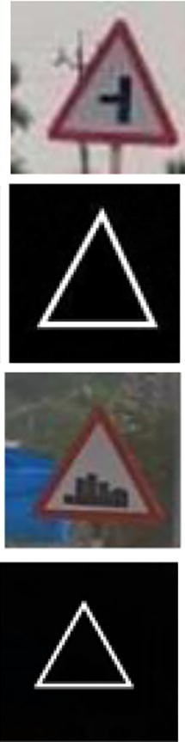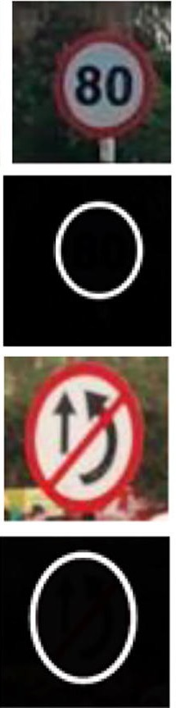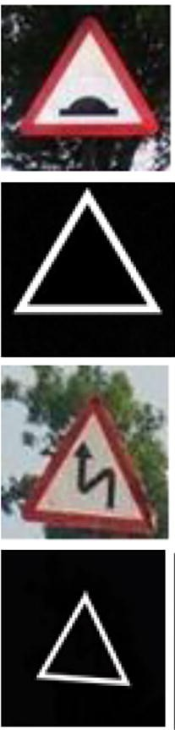
Fig. 6. Sample traffic signs and their corresponding annotation masks.

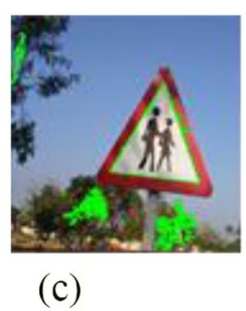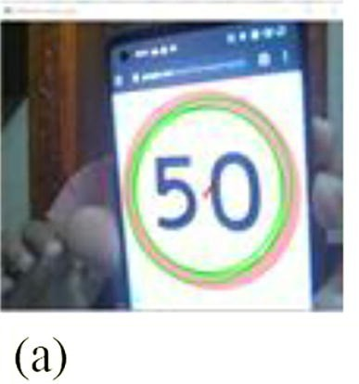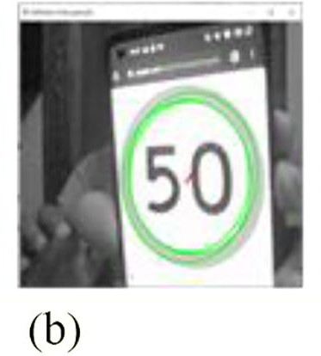
Fig. 7. ROI is marked in green colour in all the three images (a), (b) and (c) indicating the outline of traffic sign
.

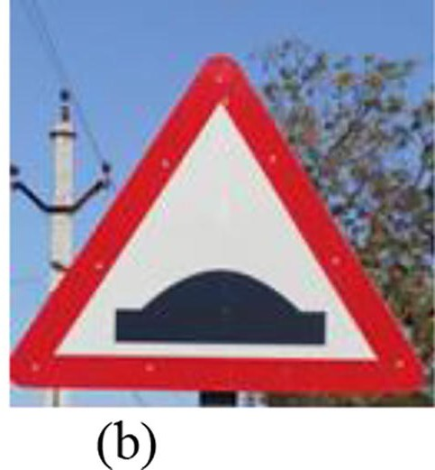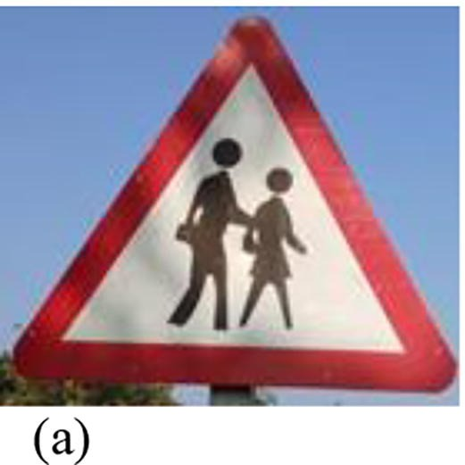
Fig. 8. Two sample images with varying brightness level. (a) Partially exposed to light. (b) Fully exposed to light.

Parametric changes

Parametric changes Even distribution of ROI: Careful choice of training samples for the RPN improves Mask R-CNN performance. Typically, ROIs are randomly sampled for foreground and background, causing an uneven ROI distribution between large and small objects—large objects require more ROIs while small objects need fewer. This biases detection toward larger objects and reduces accuracy for smaller ones. We mitigate this by evenly distributing ROIs among objects, using an equal number of ROIs per object.
Changing weights: When region proposals are missed, Mask R-CNN cannot reach 100% recall. During training, more background regions are often sampled than foreground ones because traffic signs are usually small. Consequently, without weighting, the model emphasizes background learning over foreground. We address this by assigning smaller weights to background regions and larger weights to foreground regions for both the RPN and classification branches. The chosen weights are 0.05 for RPN and 0.2 for the classification network.

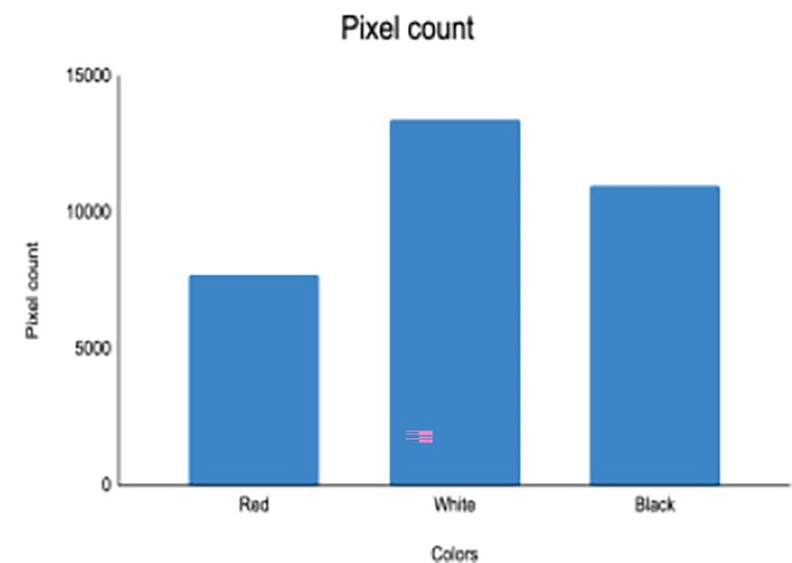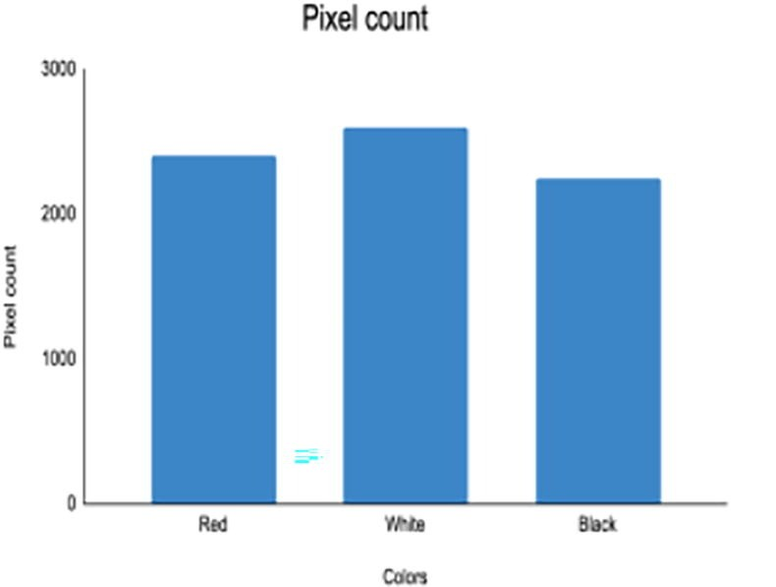
Fig. 9. Results of pixel count of colours. X-axis has colours and Y-axis has the corresponding pixel count value. (a) Pixel count for 8(a). (b) Pixel count for 8(b).

V. EXPERIMENTAL RESULTS
A large training set is crucial for high accuracy because deep models contain millions of learnable parameters. Collecting tens of thousands of real images is often impractical; data augmentation helps expand dataset size by varying image parameters. We applied eight augmentation methods:
- Image Rotation: Rotate clockwise or counterclockwise; empty pixels are filled with adjacent pixel values.
- Horizontal Flipping: Mirror the image across the vertical axis.
- Brightness Change: Darken the image by subtracting a constant from all pixels.
- Zoom In: Crop and zoom into the image by 25%, optionally combined with reduced brightness to vary appearance.
- Right Shift: Shift the image right by trimming right-edge pixels and filling the left-side gaps with adjacent pixel values.
- Left Shift: Shift left by trimming left-edge pixels and filling right-side gaps with adjacent pixel values.
- Top Shifting: Move objects upward by removing top pixels, shifting lower pixels upward, and filling the bottom with adjacent pixels.
- Bottom Shifting: Move objects downward by removing bottom pixels, shifting top pixels downward, and filling the top with adjacent pixels.
Fig. 10 displays sample augmented images, which introduce additional variability into the dataset.
Traffic sign detection using Fast R-CNN We trained Fast R-CNN and Mask R-CNN on the custom dataset to benchmark against RMR-CNN. A drawback of R-CNN is long testing time (≈47 s per image), motivating Faster R-CNN. Fast R-CNN (Girshick, 2015) replaces the pooling layer with an ROI pooling layer; outputs feed SoftMax and bounding-box regression branches. SoftMax yields class probabilities for each ROI, including background. Fast R-CNN trained on our dataset achieved 0.93 accuracy. Fig. 11 shows epochs versus loss, where training loss exceeded validation loss.

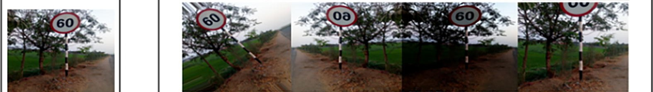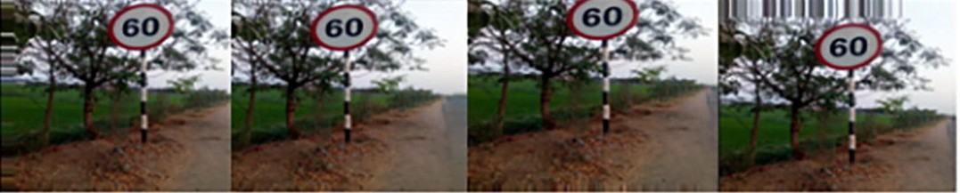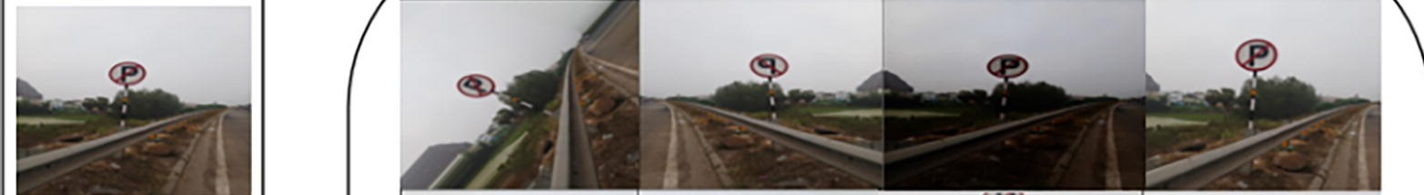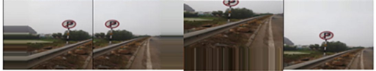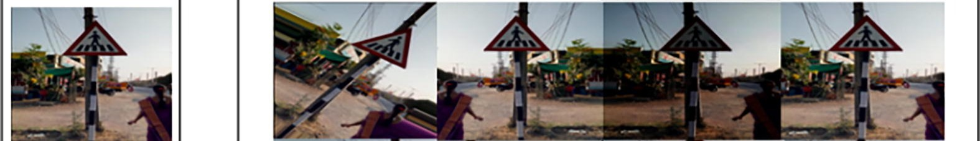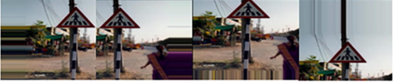
Fig. 10. Samples of data augmentation techniques.

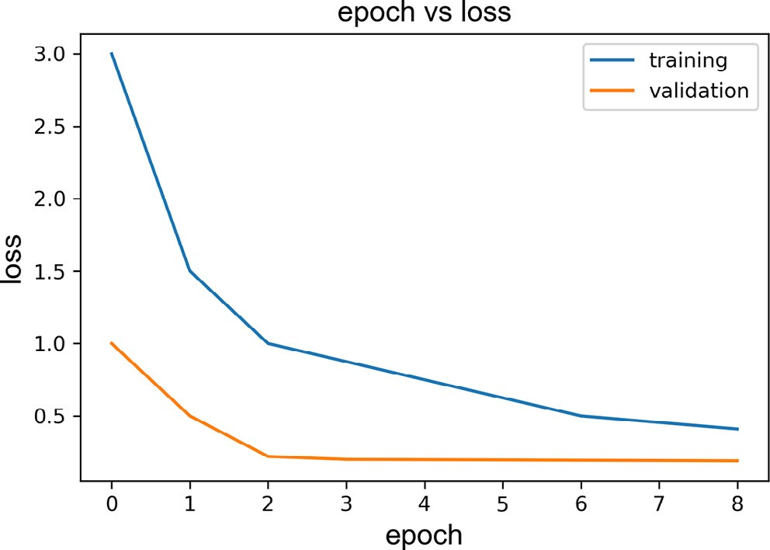
Fig. 11. Epoch vs. loss. In the graph X-axis shows the epoch value and Y-axis shows the loss value.

Traffic sign detection using Mask R-CNN

Traffic sign detection using Mask R-CNN Mask R-CNN (He et al., 2017) builds on Fast R-CNN. Detector models have two convolutionally connected components. The RPN proposes bounding boxes likely to contain objects (Abbas and Singh, 2018), while the Fast R-CNN module classifies objects inside those boxes. Mask R-CNN employs a Feature Pyramid Network (Lin et al., 2017) to retain features at multiple resolutions and replaces VGG16 with residual networks for better performance (Simonyan and Zisserman, 2015). Mask R-CNN trained and validated on the custom dataset achieved 0.94 accuracy. Fig. 12 plots epoch versus loss, showing validation loss lower than training loss.

Traffic sign detection using Refined Mask R-CNN

This section evaluates the proposed RMR-CNN detector, which augments Mask R-CNN with improved ROI distribution, foreground/background weighting, data augmentation, and parameter tuning. RMR-CNN (described in Section IV) achieved 0.974 accuracy. Fig. 13 presents epoch vs. loss for RMR-CNN with augmentation; loss decreases with iterations while detection accuracy rises as the model better learns parameters. Fig. 14 demonstrates RMR-CNN’s detection capabilities across all three Indian sign categories. Fig. 15 shows detection of various road traffic signs with intra-category variations.

Traffic sign recognition

Traffic sign recognition This section describes sign recognition using OCR-focused techniques and histogram matching.

Optical character recognition

Standard Mask R-CNN handles detection of non-textual signs. For masked images containing numeric or textual characters, OCR is applied to extract those characters. This approach is necessary because circular and triangular signs often carry critical numeric/textual information (Mainkar et al., 2020). We enhanced the basic OCR model (Mainkar et al.) using easyocr to meet the low-latency and high-accuracy requirements of this study.

Histogram matching

OCR only recognizes signs containing text. For purely graphical signs, histogram matching is used. A matching threshold of 0.82 is applied: when the similarity between the derived image and a stored sign instance exceeds this threshold, the input is assigned to that sign category. In RMR-CNN, we first check if the masked crop contains characters; if so, OCR is used; otherwise, histogram matching identifies the sign. Fig. 16 shows cropped and masked images used for OCR and histogram matching.

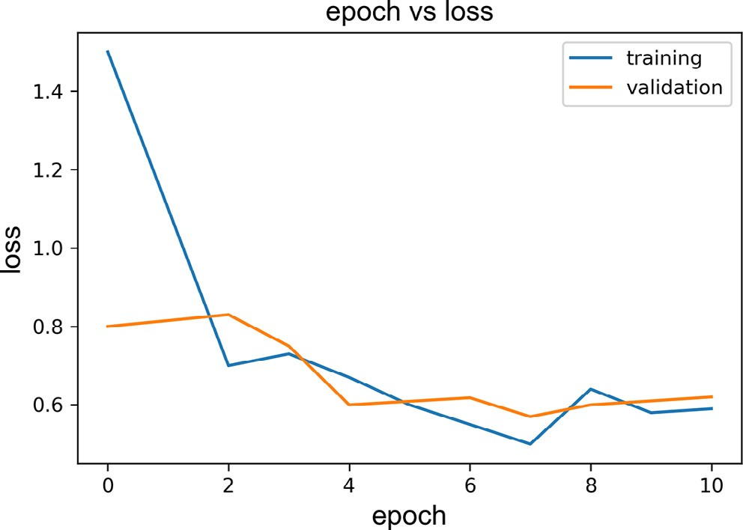
Fig. 12. Epoch vs. loss values for Mask R-CNN. In the graph X-axis shows the epoch value and Y-axis shows the loss value.

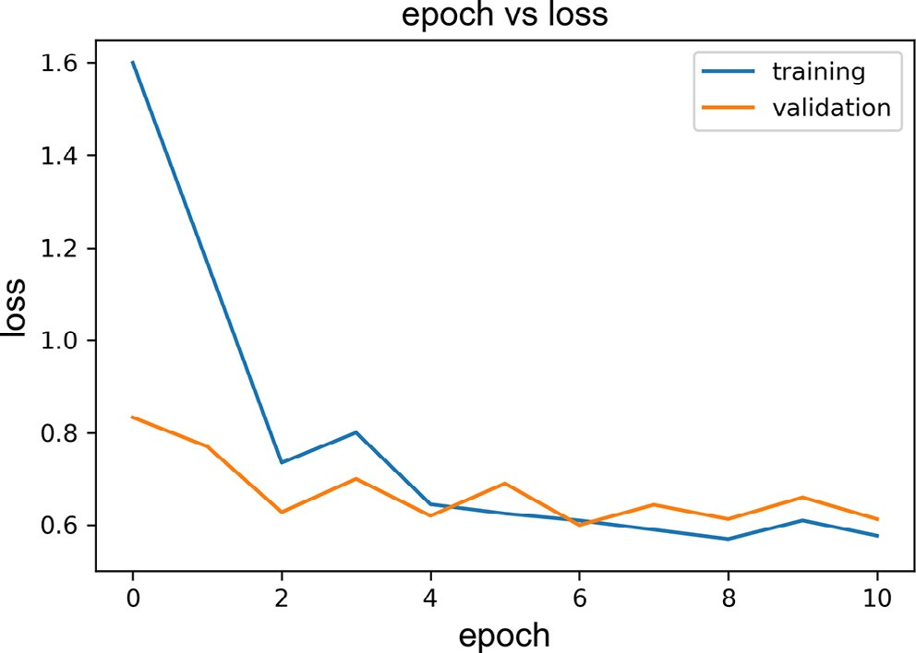
Fig. 13. Epoch vs loss value for Mask R-CNN with model changes and data augmentation.

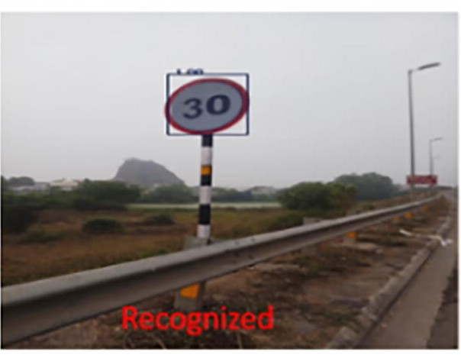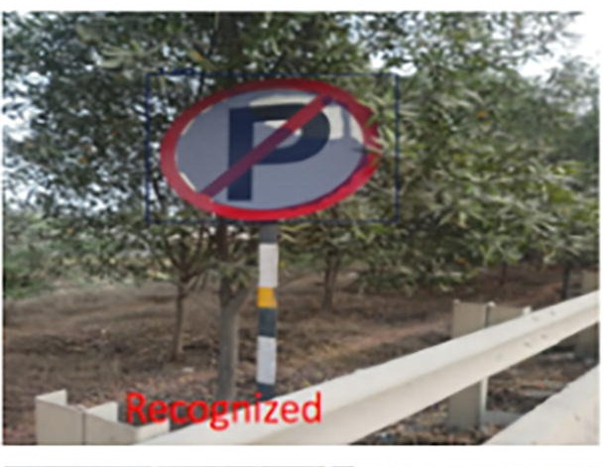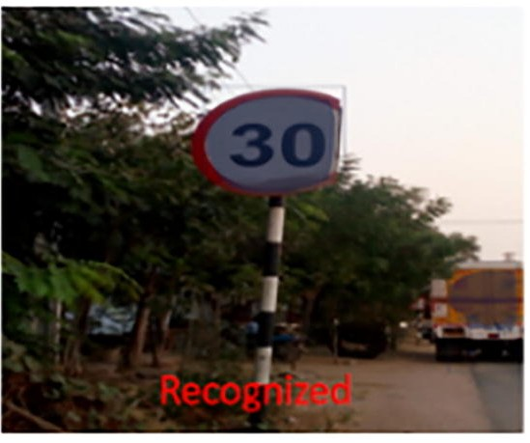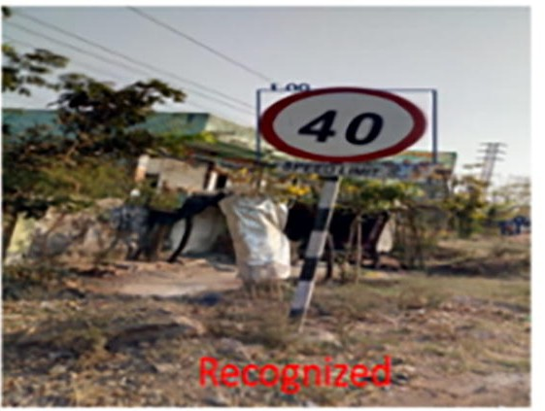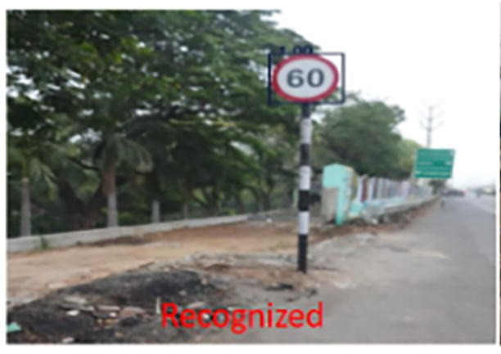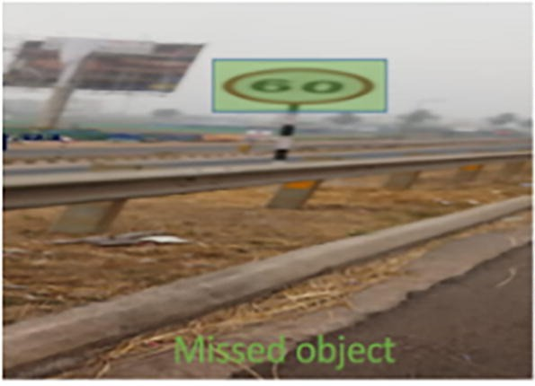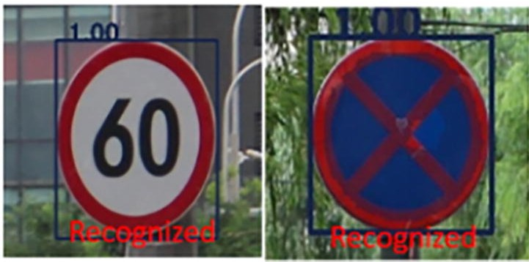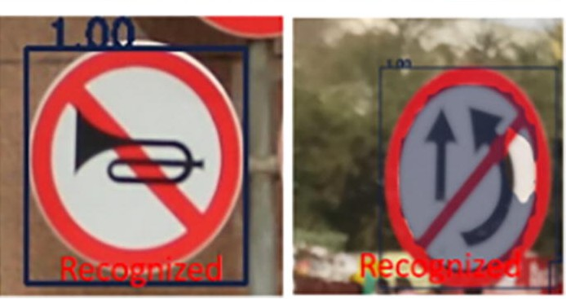
Fig. 14. Examples of Traffic Signs with various signs.

Evaluation
Hyperparameters set in our experiments include epochs, batch size, and minimum/maximum image dimensions. We used a manual tuning approach—testing various settings and comparing test-set accuracies—rather than automated optimization. Epochs were set to 20 and batch size to 100 images. Minimum image dimension was 32 × 32 pixels; maximum image dimension was 2048 × 1080 pixels. Larger batch sizes exploit GPU parallelism but may harm generalization, while excessive epochs can cause overfitting.
Table 1 reports precision and recall for traffic sign detection with RMR-CNN. The model achieved an average precision of 99.6% and recall of 96.75%. Recognition precision is expected to be somewhat lower than detection since recognition adds extra processing steps that can reduce precision. For comparison, Table 2 lists Precision and Recall for Fast R-CNN and Mask R-CNN. Results show Fast R-CNN precision/recall of 93.05%/94% (miss rate 6%, false positive rate 6.95%); Mask R-CNN improved precision to 94.4% and recall to 96.7%, lowering false positives to 5.6% and miss rate to 3.3%. Using data augmentation and refinements, RMR-CNN reached 97.08% precision and 96.75% recall with a false positive rate of 2.92%, outperforming both Fast R-CNN and Mask R-CNN. Table 3 summarizes precision, recall, and F-measure for the three models. Fig. 17 shows RMR-CNN obtained 97.08% precision with a miss rate of 3.25% and false positive rate of 2.92%, reflecting the improvements from our adaptations. Compared to Fast R-CNN and Mask R-CNN without adaptations (error rates 6% and 3.3%), RMR-CNN’s error rate of 3.25% is nearly half of Fast R-CNN’s and shows superior accuracy among the compared models.

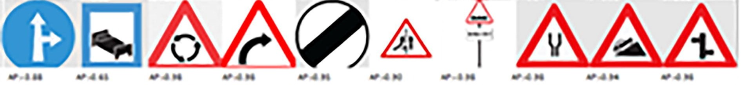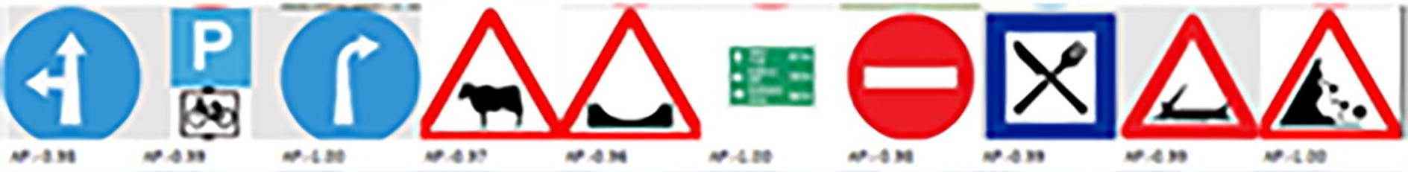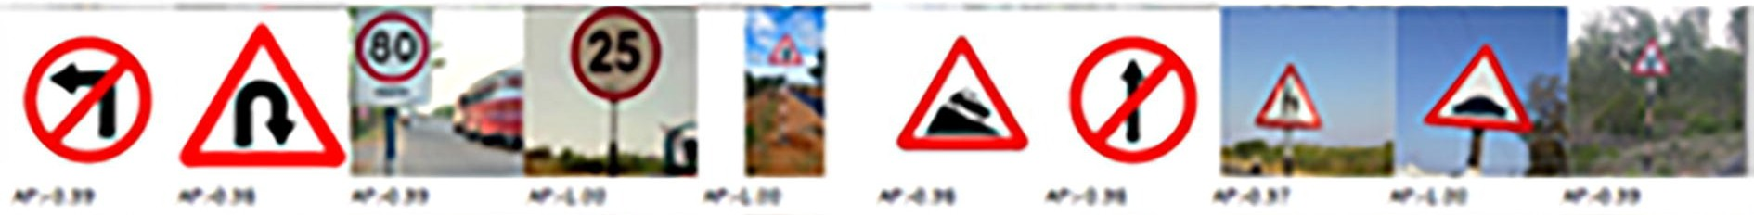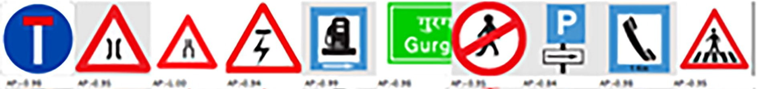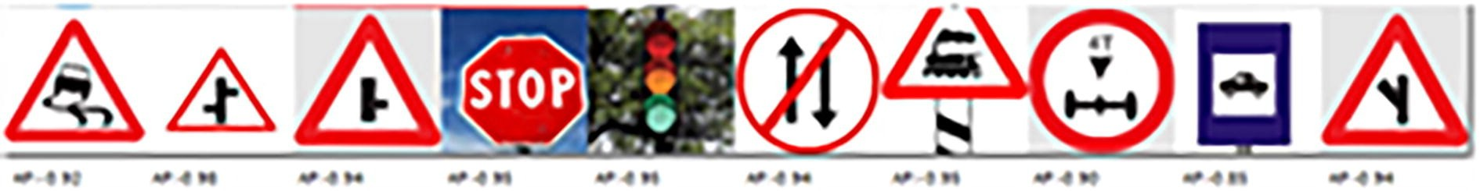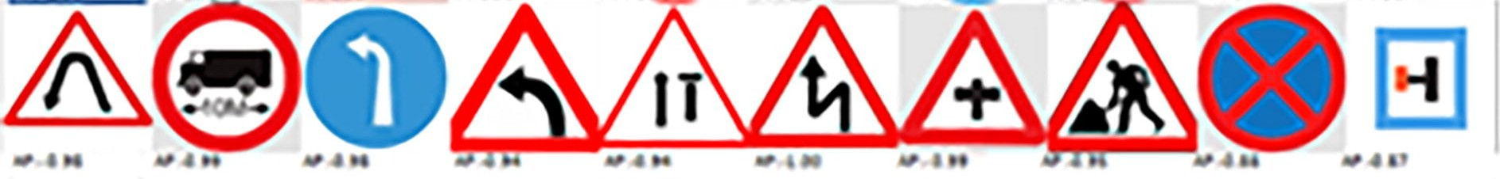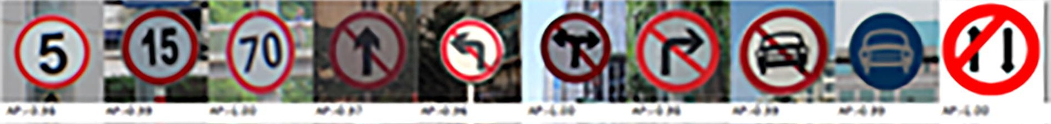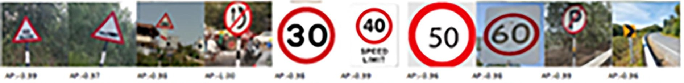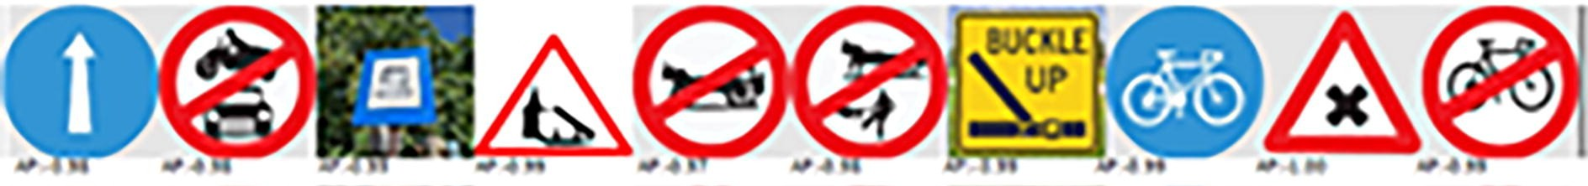Fig. 15. Road Traffic Sign categories, sorted by the proposed RMR-CNN method.
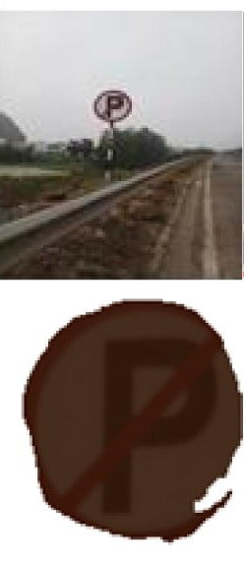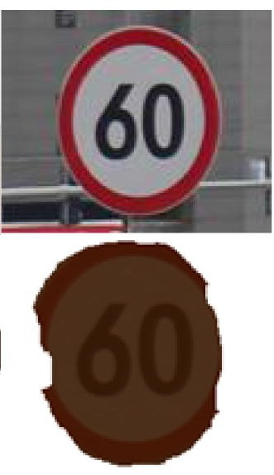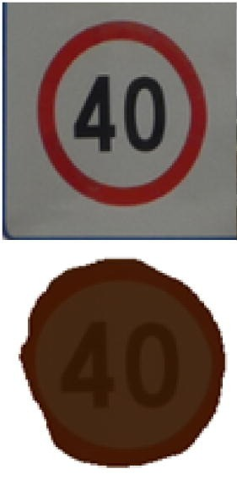
Fig. 16. Cropped image and masked image using OCR and histogram matching.
Table 1
Results of Traffic Sign detection.
RMR-CNN
Traffic sign
Precision (%) Recall (%)
Speed 30 | 100 | 100
Speed 40 | 100 | 98.4
Speed 60 | 99.7 | 97.5
Speed 70 | 100 | 100
Speed 80 | 99 | 91.2
No horn | 100 | 90.5
Warning | 98.9 | 98.1
Average | 99.6 | 96.75
Table 2
Precision and Recall % comparison for Traffic Sign detection.
Traffic sign Fast R-CNN Mask RCNN RMR-CNN

 | Prec  (%) | Rec  (%) | Prec  (%) | Rec  (%) | Prec  (%) | Rec  (%)
Sign 40 | 92.1 | 92.5 | 98 | 96.5 | 98.7 | 97.6
Sign 60 | 91.3 | 97.1 | 94.5 | 97.3 | 99.5 | 98.1
Sign 70 | 92.4 | 92.4 | 81.4 | 99.1 | 88.7 | 98.5
Go left | 99.1 | 94.2 | 99.5 | 92.4 | 98.6 | 93.6
Go right | 98.9 | 95.1 | 94.6 | 95.5 | 96.3 | 95.1
warning | 81.2 | 91.5 | 96.5 | 96.5 | 98.7 | 98.5
Speed 80 | 96.4 | 95.2 | 96.8 | 96.8 | 99.1 | 95.9
Average | 93.05 | 94 | 94.4 | 96.7 | 97.08 | 96.75
Note: Prec – Precision, Rec – Recall.

Table 3
Precision, recall, and F measure for all three models.
Average | Fast RCNN (%) | Mask RCNN (%) | RMR-CNN (%)
Precision | 93 | 94.4 | 97.08
Recall | 94 | 96.7 | 96.75
F-measure | 93.4 | 95.53 | 96.87

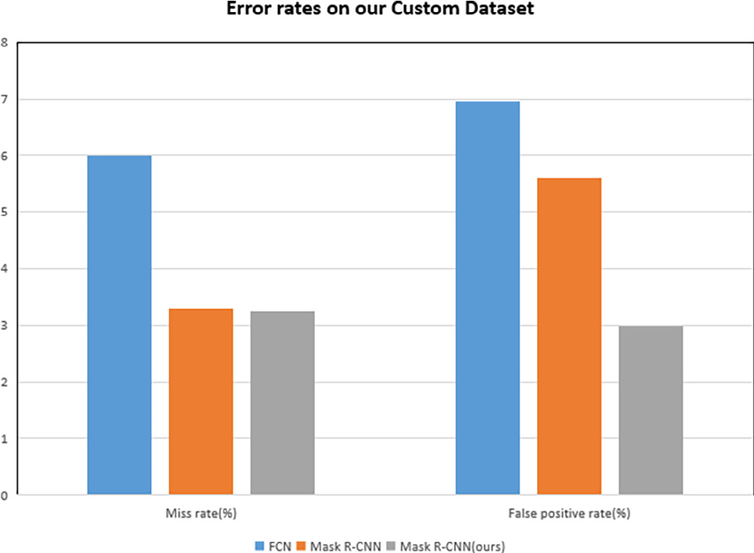
Fig. 17. Miss rates and false positive rates on Traffic Sign dataset.

VI. DISCUSSION
Results indicate that deep learning substantially improves traffic sign recognition performance compared to traditional methods. The proposed approach enables accurate and near-real-time classification, making it suitable for autonomous driving and intelligent transport applications. Convolutional networks automatically learn complex image features, enhancing both accuracy and robustness. Preprocessing and augmentation further help the model handle lighting, weather, and occlusions.

VII. CONCLUSION

We presented a practical deep-learning approach for detecting and recognizing road traffic signs that performs well under varied lighting, orientation, and scale conditions. RMR-CNN, a refined Mask R-CNN variant, includes architectural adjustments, expanded data augmentation, and parameter refinements. A novel real-time custom dataset was assembled for training and validation. Alongside augmentation, specific adaptations to the baseline CNN contributed to RMR-CNN’s accurate, efficient, and rapid detection across a substantial set of sign categories. Performance gains are evidenced by notable reductions in miss and false positive rates. RMR-CNN outperformed Fast R-CNN and Mask R-CNN in precision, recall, and F-measure. The total error rate of about 3% is mainly attributable to sign similarity, occlusion, and large viewing angles; this could be further reduced by capturing multiple instances with stereo cameras. The authors suggest pursuing additional enhancements to RMR-CNN for recognizing dirty or obscured signs (Majid and Heaslip, 2016) and further lowering miss and false positive rates.
Conflict of Interest
The authors declare that they have no known competing financial interests or personal relationships that could have appeared to influence the work reported in this paper.
REFERENCES
Abbas, S.M., Singh, D.S.N., 2018. Region-based object detection and classification using faster R-CNN. In: 2018 4th International Conference on Computational Intelligence & Communication Technology (CICT), pp. 1–6. https://doi.org/10.1109/CIACT.2018.8480413.
Avramovic´, A., Sluga, D., Tabernik, D., Skocˇaj, D., Stojnic´, V., Ilc, N., 2020. Neural-network-based traffic sign detection and recognition in high-definition images using region focusing and parallelization. IEEE Access 8, 189855–189868. https://doi.org/10.1109/ACCESS.2020.3031191.
Aziz, L., Haji Salam, M.S.B., Sheikh, U.U., Ayub, S., 2020. Exploring deep learning-based architecture, strategies, applications and current trends in generic object detection: A comprehensive review. IEEE Access 8, 170461–170495. https://doi.org/10.1109/ACCESS.2020.3021508.
Chen, T., Lu, S., 2016. Accurate and efficient traffic sign detection using discriminative AdaBoost and support vector regression. IEEE Trans. Veh. Technol. 65 (6), 4006–4015. https://doi.org/10.1109/TVT.2015.2500275.
Girshick, R., (2015). Fast R-CNN. IEEE International Conference on Computer Vision (ICCV), Santiago, Chile, 2015, pp. 1440-1448, doi: 10.1109/ ICCV.2015.169.
Greenhalgh, J., Mirmehdi, M., 2012. Real-time detection and recognition of road traffic signs. IEEE Trans. Intell. Transp. Syst. 13 (4), 1498–1506. https://doi. org/10.1109/TITS.2012.2208909.
Greenhalgh, J., Mirmehdi, M., 2015. Recognizing text-based traffic signs. IEEE Trans. Intell. Transp. Syst. 16 (3), 1360–1369. https://doi.org/10.1109/ TITS.2014.2363167.
Guo, J., You, R., Huang, L., 2020. Mixed vertical-and-horizontal-text traffic sign detection and recognition for street-level scene. IEEE Access 8, 69413–69425. https://doi.org/10.1109/ACCESS.2020.2986500.
He, K., Gkioxari, G., Dollár, P., Girshick, R., (2017). Mask R-CNN. In: 2017 IEEE International Conference on Computer Vision (ICCV), Venice, Italy, pp. 29802988, doi: 10.1109/ICCV.2017.322.
Houben, S., Stallkamp, J., Salmen, J., Schlipsing, M., Igel, C., 2013. Detection of traffic signs in real-world images: The German traffic sign detection benchmark. Proc. IJCNN, 1–8.
Hu, Q., Paisitkriangkrai, S., Shen, C., van den Hengel, A., Porikli, F., 2016. Fast detection of multiple objects in traffic scenes with a common detection framework. IEEE Trans. Intell. Transp. Syst. 17 (4), 1002–1014. https://doi.org/10.1109/TITS.2015.2496795.
Huang, Z., Yu, Y., Gu, J., Liu, H., 2017. An efficient method for traffic sign recognition based on extreme learning machine. IEEE Trans. Cybern. 47 (4), 920– 933.
Kamada, H., Naoi, S., Gotoh, T. (1990). A compact navigation system using image processing and fuzzy control. In: IEEE Proceedings on Southeastcon, 1990, pp. 337-342 vol.1, doi: 10.1109/SECON.1990.117829.
Kamal, U., Tonmoy, T.I., Das, S., Hasan, M.K., 2019. Automatic traffic sign detection and recognition using SegU-Net and a modified Tversky loss function with L1-constraint. IEEE Trans. Intell. Transp. Syst. 1–13. https://doi.org/10.1109/tits.2019.2911727.
Lee, H.S., Kim, K., 2018. Simultaneous traffic sign detection and boundary estimation using convolutional neural network. IEEE Trans. Intell. Transp. Syst. 19 (5), 1652–1663. https://doi.org/10.1109/TITS.2018.2801560.
Lin, T.-Y., Dollár, P., Girshick, R., He, K., Hariharan, B., Belongie, S., 2017. Feature pyramid networks for object detection. Proc. Comput. Vis. Pattern Recognit., 936–944
Liu, C., Chang, F., Chen, Z., Liu, D., 2016. Fast traffic sign recognition via high-contrast region extraction and extended sparse representation. IEEE Trans. Intell. Transp. Syst. 17 (1), 79–92. https://doi.org/10.1109/TITS.2015.2459594.
Lopez-Montiel, M., Orozco-Rosas, U., Sanchez-Adame, M., Picos, K., Ross, O.H.M., 2021. Evaluation method of deep learning-based embedded systems for traffic sign detection. IEEE Access 9, 101217–101238.
Luo, H., Yang, Y., Tong, B., Wu, F., Fan, B., 2018. Traffic sign recognition using a multi-task convolutional neural network. IEEE Trans. Intell. Transp. Syst. 19 (4), 1100–1111. https://doi.org/10.1109/TITS.2017.2714691.
Mainkar, V.V., Katkar, J.A., Upade, A.B., Pednekar, P.R., 2020. Handwritten character recognition to obtain editable text. In: 2020 International Conference on Electronics and Sustainable Communication Systems (ICESC), pp. 599–602. https://doi.org/10.1109/ICESC48915.2020.9155786.
Majid, K., Heaslip, K., 2016. Analysis of factors temporarily impacting traffic sign readability. Int. J. Transp. Sci. Technol. 5 (2), 60–67. https://doi.org/10.1016/ j.ijtst.2016.09.003. ISSN2046-0430.
Mammeri, A., Boukerche, A., Almulla, M., 2013. Design of traffic sign detection, recognition, and transmission systems for smart vehicles. IEEE Wireless Commun. 20 (6), 36–43.
Mogelmose, A., Trivedi, M.M., Moeslund, T.B., 2012. Vision-based traffic sign detection and analysis for intelligent driver assistance systems: Perspectives and survey. IEEE Trans. Intell. Transp. Syst. 13 (4), 1484–1497.
Segvic, S., Brkic, K., Kalafatic, Z., Stanisavljevic, V., Sevrovic, M., Budimir, D., Dadic, I. (2010). A computer vision assisted geoinformation inventory for traffic infrastructure. In: Proc. 13th Int. IEEE Conf. Intell. Transp. Syst. (ITSC), pp. 66–73.
Simonyan, K., Zisserman, A., 2015. Very deep convolutional networks for large-scale image recognition. Proc. Int. Conf. Learn. Represent., 1–14
Stallkamp, J., Schlipsing, M., Salmen, J., Igel, C., 2012. Man vs. Computer: Benchmarking machine learning algorithms for traffic sign recognition. Neural Netw. 32, 323–332.
Temel, D., Chen, M.H., AlRegib, G., 2020. Traffic sign detection under challenging conditions: a deeper look into performance variations and spectral characteristics. IEEE Trans. Intell. Transp. Syst. 21 (9), 3663–3673. https://doi.org/10.1109/TITS.2019.2931429.
Timofte, R., Prisacariu, V., Van Gool, L., Reid, I., 2011. Combining traffic sign detection with 3D tracking towards better driver assistance. In: Emerging Topics in Computer Vision and Its Applications. World Scientific, Singapore, pp. 425–446. https://doi.org/10.1142/8103.
Wong, A., Shafiee, M.J., St. Jules, M., 2018. MicronNet: a highly compact deep convolutional neural network architecture for real-time embedded traffic sign classification. IEEE Access 6, 59803–59810.
Yang, Y., Luo, H., Xu, H., Wu, F., 2016. Towards real-time traffic sign detection and classification. IEEE Trans. Intell. Transp. Syst. 17 (7), 2022–2031. https:// doi.org/10.1109/TITS.2015.2482461.
Zaklouta, F., Stanciulescu, B., 2012. Real-time traffic-sign recognition using tree classifiers. IEEE Trans. Intell. Transp. Syst. 13 (4), 1507–1514.
Zhang, D., Chen, X., Li, F., Sangaiah, A.K., Ding, X., Gao, H., 2020. Seam-carved image tampering detection based on the cooccurrence of adjacent LBPs. Secur. Commun. Netw. 2020, 12. https://doi.org/10.1155/2020/8830310. Article ID 8830310.
Zhang, D., Li, Q., Yang, G., Li, L., Sun, X., 2017. Detection of image seam carving by using weber local descriptor and local binary patterns. J. Inf. Secur. Appl. 36, 135–144.
Zhang, J., Sun, J., Wang, J., Yue, X.-G., 2021. Visual object tracking based on residual network and cascaded correlation filters. J. Ambient Intell. Human Comput. 12 (8), 8427–8440.
Zhou, S., Qiu, J., 2021. Enhanced SSD with interactive multi-scale attention features for object detection. Multimed. Tools Appl. 80, 11539–11556. https:// doi.org/10.1007/s11042-020-10191-2.
Zhu, Y., Zhang, C., Zhou, D., Wang, X., Bai, X., Liu, W., 2016a. Traffic sign detection and recognition using fully convolutional network guided proposals ISSN 0925-2312 Neurocomputing 214, 758–766. https://doi.org/10.1016/j.neucom.2016.07.009.
Zhu, Z., Liang, D., Zhang, S., Huang, X., Li, B., Hu, S., 2016b. Traffic sign detection and classification in the wild. Proc. CVPR, 2110–2118.
Further Reading
He, S., Chen, L., Zhang, S., Guo, Z., Sun, P., Liu, H., Liu, H., 2021. Automatic recognition of traffic signs based on visual inspection. IEEE Access 9, 43253–43261.
https://doi.org/10.1109/ACCESS.2021.3059052.

